3ellissa Jr. Course

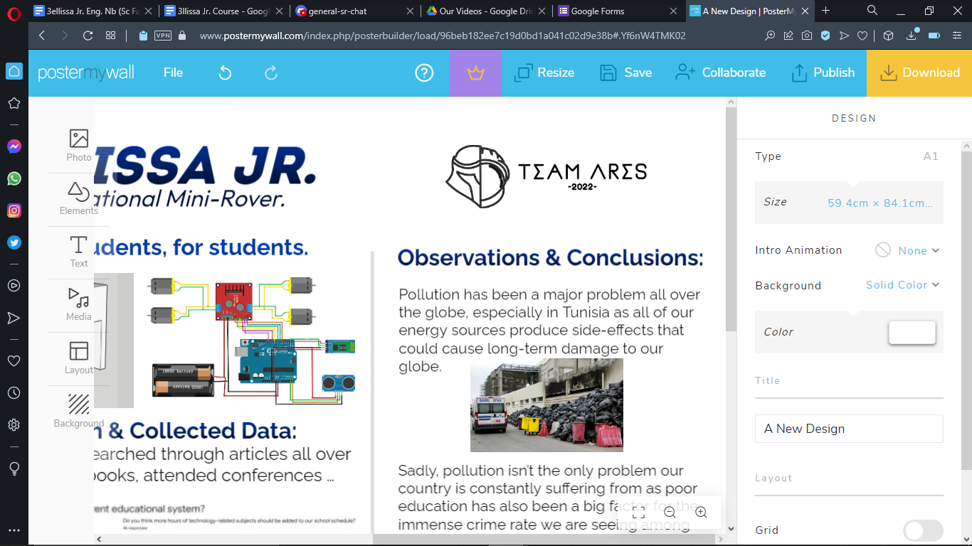

–By Team Ares on February, 2, 2022.

Written & Edited by: E. Lahiani.

## **Team Members:**

| Eya Lahiani, 15  Engineering Notebook Writer - Organiser  Coach in the First Skills Club | Mohammed Hedi Ben Jmeaa, 15  Incharge of designing, media and wiring  Coach In the First Skills Club | Mahdi Madani, 15  Incharge of wiring of the electronics  Assistant in the First Skills Club |
| --- | --- | --- |

# What is Arduino?

Arduino is an open-source electronics platform based on easy-to-use hardware and software. [Arduino boards](https://www.arduino.cc/en/Main/Products) are able to read inputs - light on a sensor, a finger on a button, or a Twitter message - and turn it into an output - activating a motor, turning on an LED, publishing something online. You can tell your board what to do by sending a set of instructions to the microcontroller on the board. To do so you use the [Arduino programming language](https://www.arduino.cc/en/Reference/HomePage) (based on [Wiring](http://wiring.org.co/)), and [the Arduino Software (IDE)](https://www.arduino.cc/en/Main/Software), based on [Processing](https://processing.org/).

Arduino was born at the Ivrea Interaction Design Institute as an easy tool for fast prototyping, aimed at students without a background in electronics and programming. As soon as it reached a wider community, the Arduino board started changing to adapt to new needs and challenges, differentiating its offer from simple 8-bit boards to products for IoT applications, wearable, 3D printing, and embedded environments.

### **1.1 Why Arduino?**

The Arduino software is easy-to-use for beginners, yet flexible enough for advanced users. It runs on Mac, Windows, and Linux. Teachers and students use it to build low cost scientific instruments, to prove chemistry and physics principles, or to get started with programming and robotics. Designers and architects build interactive prototypes, musicians and artists use it for installations and to experiment with new musical instruments. Makers, of course, use it to build many of the projects exhibited at the Maker Faire, for example. Arduino is a key tool to learn new things. Anyone - children, hobbyists, artists, programmers - can start tinkering just following the step by step instructions of a kit, or sharing ideas online with other members of the Arduino community.

Arduino also simplifies the process of working with microcontrollers, but it offers some advantage for teachers, students, and interested amateurs over other systems:

* **Inexpensive** - Arduino boards are relatively inexpensive compared to other microcontroller platforms. The least expensive version of the Arduino module can be assembled by hand, and even the pre-assembled Arduino modules cost less than $50
* **Cross-platform** - The Arduino Software (IDE) runs on Windows, Macintosh OSX, and Linux operating systems. Most microcontroller systems are limited to Windows.
* **Simple, clear programming environment** - The Arduino Software (IDE) is easy-to-use for beginners, yet flexible enough for advanced users to take advantage of as well. For teachers, it's conveniently based on the Processing programming environment, so students learning to program in that environment will be familiar with how the Arduino IDE works.
* **Open source and extensible software** - The Arduino software is published as open source tools, available for extension by experienced programmers. The language can be expanded through C++ libraries, and people wanting to understand the technical details can make the leap from Arduino to the AVR C programming language on which it's based. Similarly, you can add AVR-C code directly into your Arduino programs if you want to.
* **Open source and extensible hardware** - The plans of the Arduino boards are published under a Creative Commons licence, so experienced circuit designers can make their own version of the module, extending it and improving it. Even relatively inexperienced users can build the [breadboard version of the module](https://www.arduino.cc/en/Main/Standalone) in order to understand how it works and save money.

# Exploring the elements in the kit:

| **Quantity, name and image of the product:** | **Description of the product / Links:** |
| --- | --- |
| 2 x L298N Motor Driver Module | This L298N Motor Driver Module is a high power motor driver module for driving DC and Stepper Motors. L298N Module can control up to 4 DC motors, or 2 DC motors with directional and speed control. |
| 1 x Arduino Uno | The Arduino Uno is an open-source microcontroller board. The board is equipped with sets of digital and analog input/output pins that may be interfaced to various expansion boards and other circuits. |
| 1 x Solar Panels / 9V battery | A solar panel works by allowing photons (particles of light) to knock electrons free from atoms, generating a flow of electricity. Solar panels actually comprise many, smaller units called photovoltaic cells. Many cells linked together make up a solar panel. |
| 4 x DC Motors | Connecting an L298 bridge IC to an Arduino enables the functioning of D(irect)C(urrent) motors. DC motors normally have just two leads, one positive and one negative. If connected directly to a battery, the motors will rotate. |
| 1 x HC-08 Bluetooth Module | HC-06 bluetooth module is a slave bluetooth module designed for wireless serial communication. It is a slave module meaning that it can receive serial data when serial data is sent out from a master bluetooth device (able to send serial data through air: smart phones, PC). |
| 1x HC-SR04 Ultrasonic Sensor | The HC-SR04 ultrasonic sensor uses SONAR (it’s a technique that uses sound propagation to navigate, measure distances...) to determine the distance of an object just like the bats do. It offers excellent non-contact range detection with high accuracy and stable readings in an easy-to-use package from 2 cm to 400 cm. |
| 2 x 6cm in diameter wheels 2 x 9cm in diameter wheels | Learn more here:   * <https://www.vexrobotics.com/228-3505.html> * <https://www.revrobotics.com/rev-41-1267/> |

# Wiring the elements:

- Wiring the motors and the L298N Motor Driver Module:

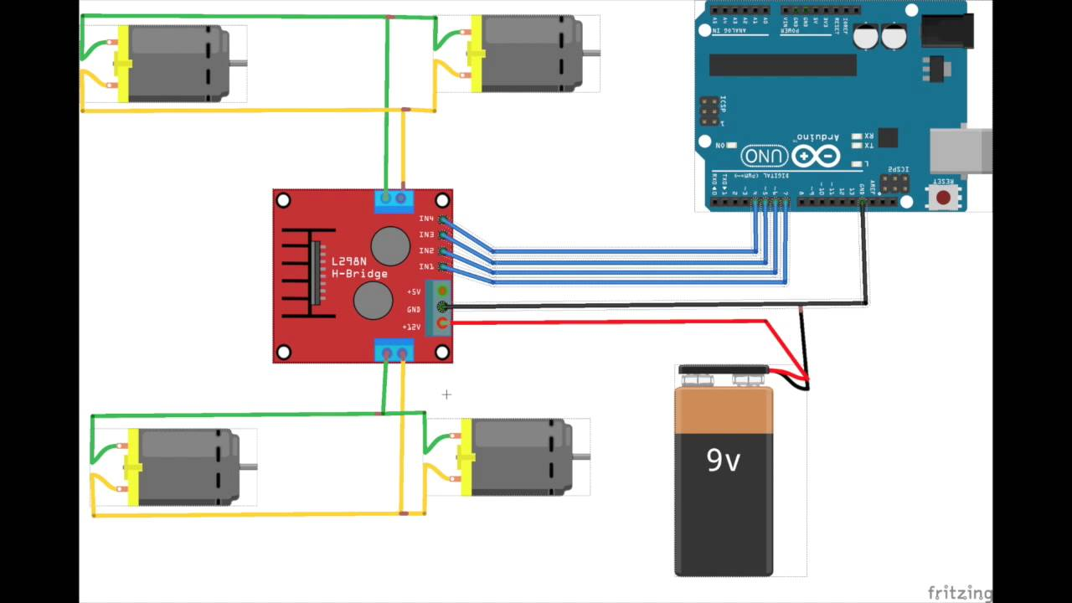

- Wiring the HC-08 Bluetooth Module:

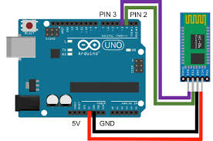

- Wiring the HC-SR04 Ultrasonic Sensor:

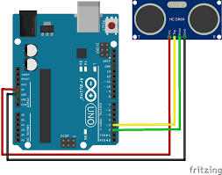

## **3.1 the full mechanism:**

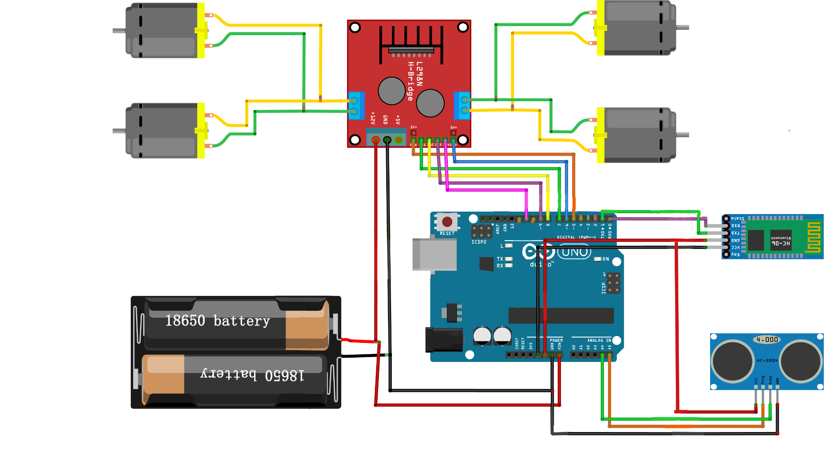

# Coding the electronic parts:

## **4.1 General Information:**

Arduino code is written in C++ with an addition of special methods and functions. C++ is a human-readable programming language. To download the coding environment, visit the official arduino website [here](https://www.arduino.cc/en/software). Once downloaded, you will be able to create a 'sketch' (the name given to Arduino code files), which will be processed and compiled to machine language when uploaded to your board after plugging in the (usually) blue wire.

**Downloading the driving app:**

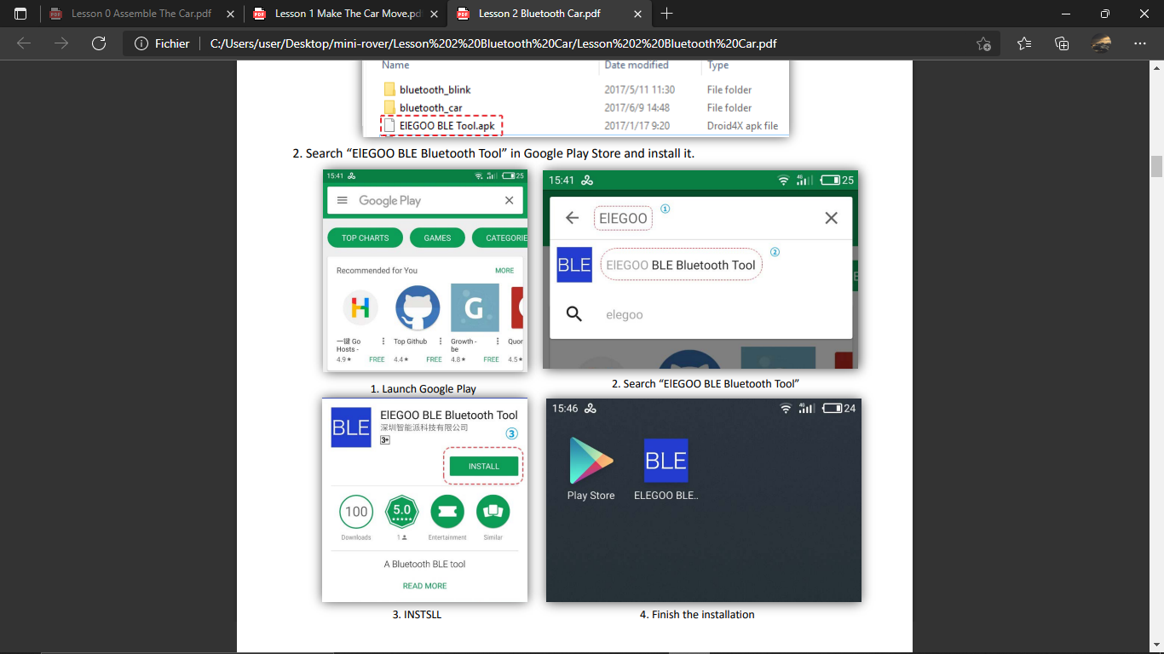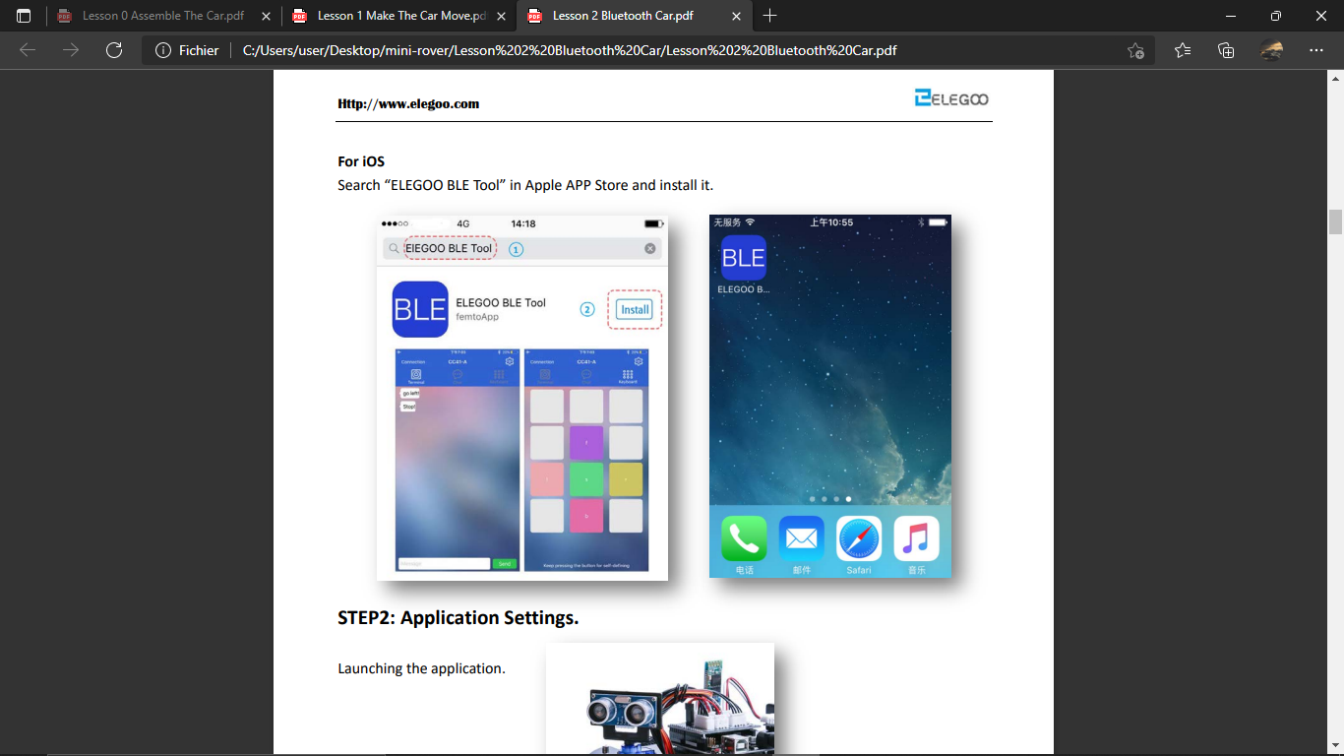

Settings configuration:

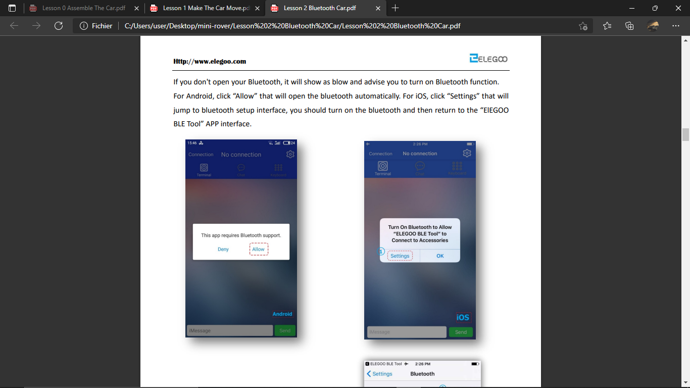

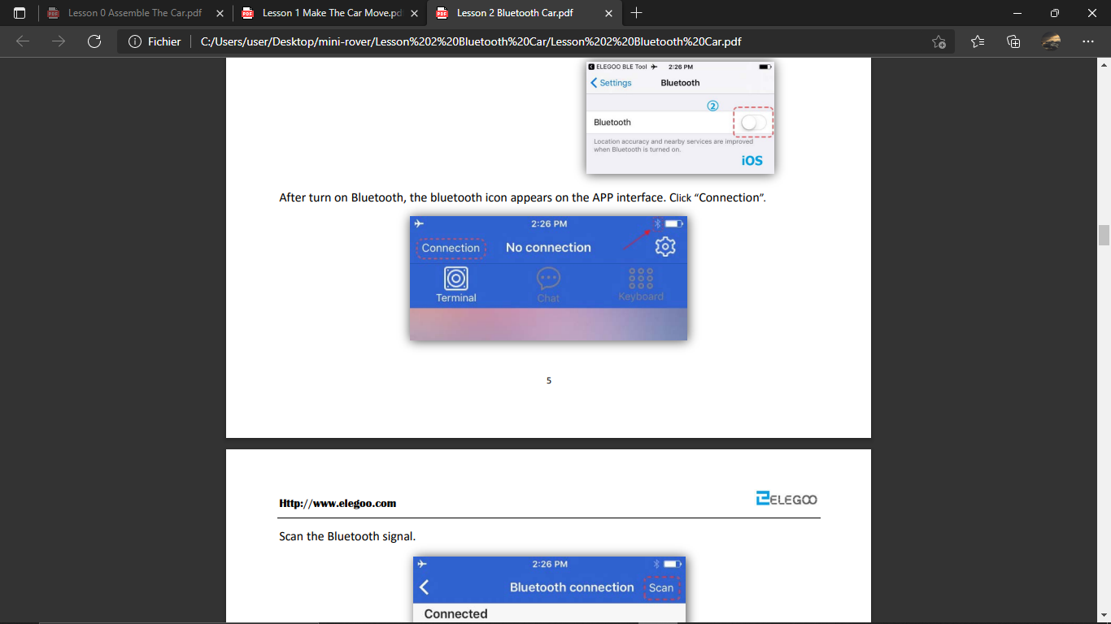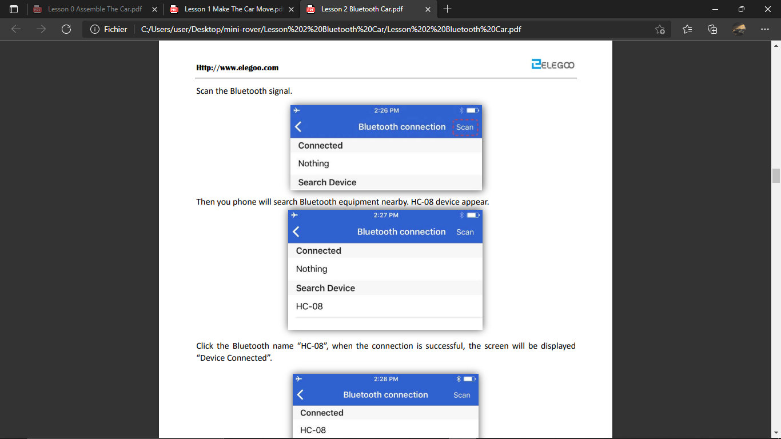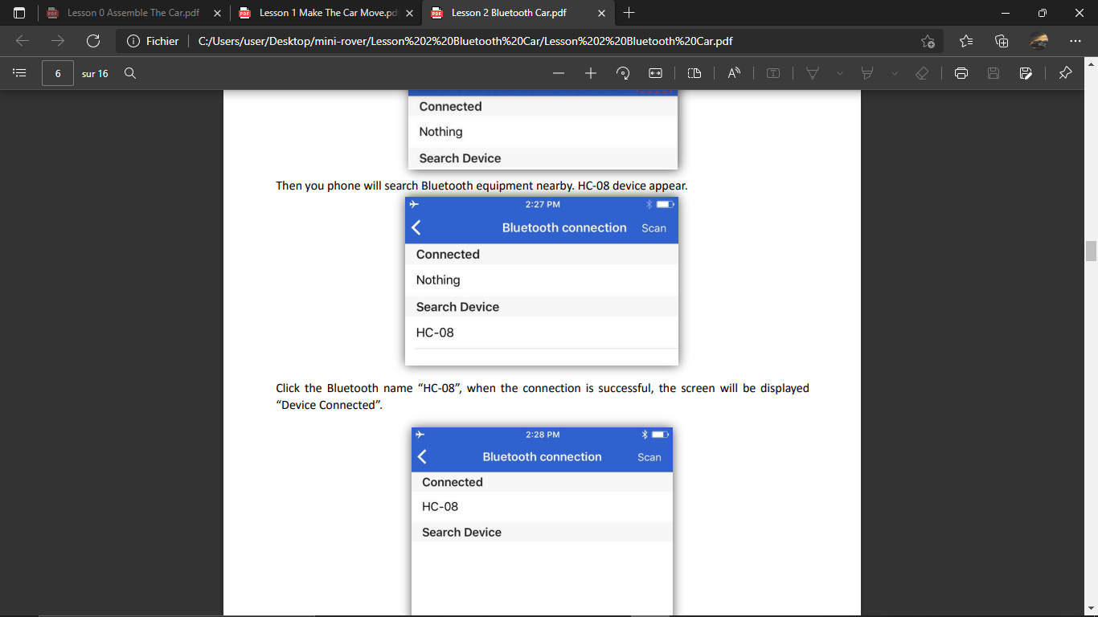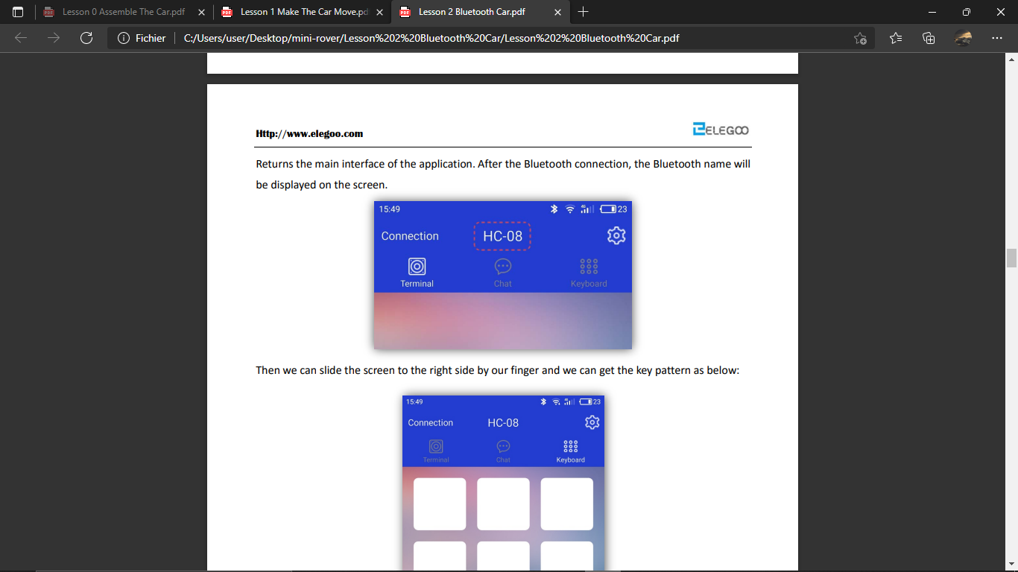

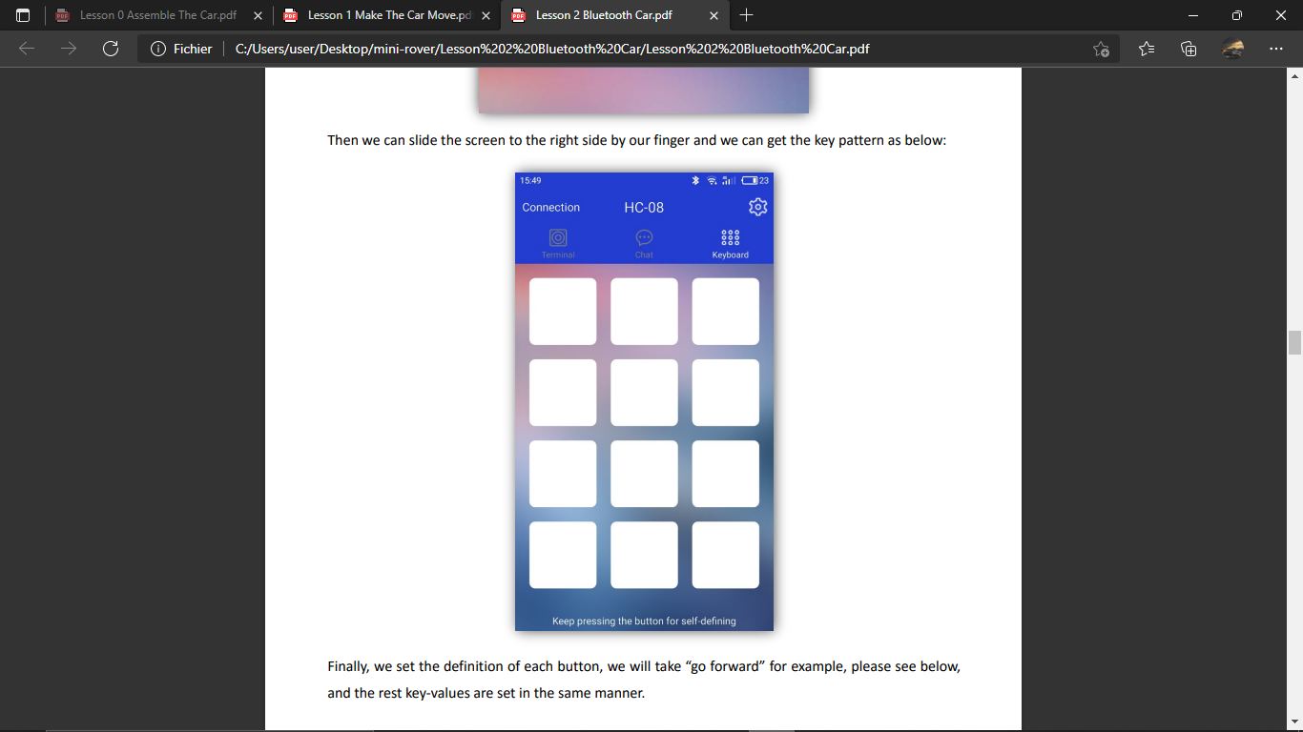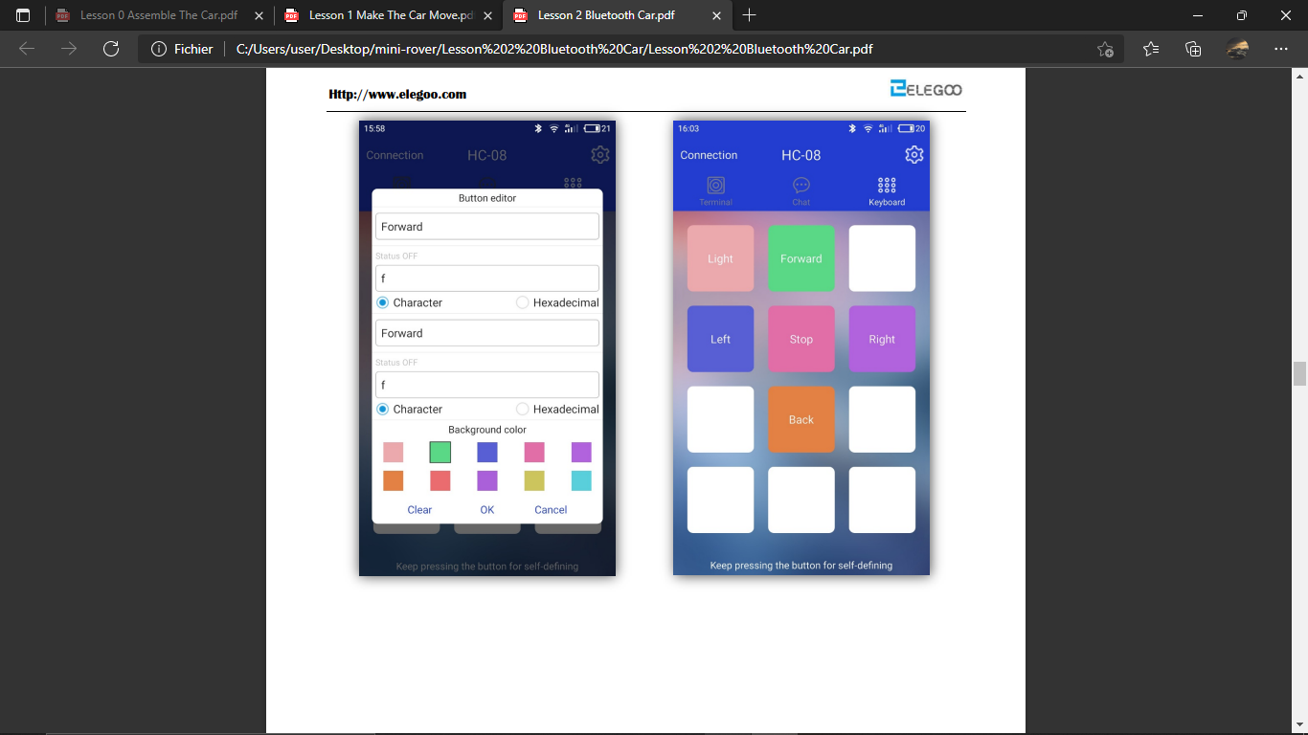

Long press the empty spaces to redefine the buttons and rename them.

## **4.2 Full code:**

#define ENA 5

#define ENB 6

#define IN1 7

#define IN2 8

#define IN3 9

#define IN4 11

#define LED 13

unsigned char carSpeed = 150;

bool state = LOW;

char getstr;

void forward(){

digitalWrite(ENA,HIGH);

digitalWrite(ENB,HIGH);

digitalWrite(IN1,HIGH);

digitalWrite(IN2,LOW);

digitalWrite(IN3,LOW);

digitalWrite(IN4,HIGH);

Serial.println("Forward");

}

void back(){

digitalWrite(ENA,HIGH);

digitalWrite(ENB,HIGH);

digitalWrite(IN1,LOW);

digitalWrite(IN2,HIGH);

digitalWrite(IN3,HIGH);

digitalWrite(IN4,LOW);

Serial.println("Back");

}

void left(){

analogWrite(ENA,carSpeed);

analogWrite(ENB,carSpeed);

digitalWrite(IN1,LOW);

digitalWrite(IN2,HIGH);

digitalWrite(IN3,LOW);

digitalWrite(IN4,HIGH);

Serial.println("Left");

}

void right(){

analogWrite(ENA,carSpeed);

analogWrite(ENB,carSpeed);

digitalWrite(IN1,HIGH);

digitalWrite(IN2,LOW);

digitalWrite(IN3,HIGH);

digitalWrite(IN4,LOW);

Serial.println("Right");

}

void stop(){

digitalWrite(ENA,LOW);

digitalWrite(ENB,LOW);

Serial.println("Stop!");

}

void stateChange(){

state = !state;

digitalWrite(LED, state);

Serial.println("Light");  
}

void setup() {

Serial.begin(9600);

pinMode(LED, OUTPUT);

pinMode(IN1,OUTPUT);

pinMode(IN2,OUTPUT);

pinMode(IN3,OUTPUT);

pinMode(IN4,OUTPUT);

pinMode(ENA,OUTPUT);

pinMode(ENB,OUTPUT);

stop();

}

void loop() {

getstr = Serial.read();

switch(getstr){

case 'f': forward();

break;

case 'b': back();

break;

case 'l': left();

break;

case 'r': right();

break;

case 's': stop();

break;

case 'a': stateChange();

break;

default: break;

}

}



– Us, E. Lahiani, M. Madani and M. H. Ben Jmeaa, in 01/02/202

All rights reserved ©TeamAres 2022

Contact us: [Teamares.tunisia@gmail.com](mailto:Teamares.tunisia@gmail.com) / 20 513 102.

